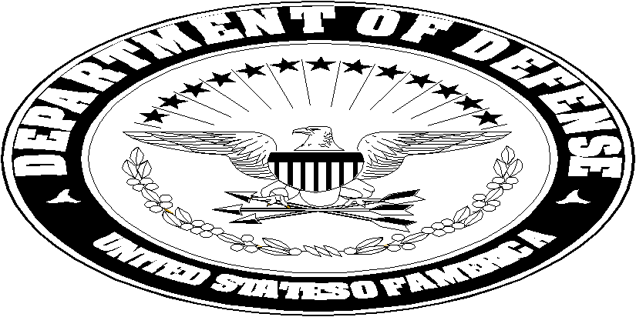 | IDAHO NATIONAL GUARD  JOINT FORCE HEADQUARTERS  3882 W. Ellsworth St., Bldg 440  Boise, Idaho 83705-8035 | 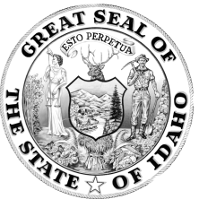
NGID-OPS-CD 22 November 2010

1. An announcement is made of the following position in the Idaho National Guard Counterdrug Support Office:

POSITION TITLE: COUNTERDRUG FIELD/DDR NCO

MOS/AFSC: MOS/AFSC IMMATERIAL

DUTY LOCATION: BOISE, IDAHO

CONSIDERATION AREA: ALL CURRENT MEMBERS OF THE IDAHO AIR OR ARMY NATIONAL GUARD LIVING WITHIN COMMUTING DISTANCE OF BOISE, IDAHO

GRADE: E1 – E5

CLOSING DATE: 10 DECEMBER 2010

GENDER LIMITATION: NONE

2. EQUAL OPPORTUNITY: The Idaho Army National Guard is an equal opportunity employer. Selection for positions will therefore be made on an equal opportunity basis, and not on non-merit factors.

3. JOB DESCRIPTION: This position is located in Boise, Idaho under the command and control of the Counterdrug Support Office located at Gowen Field. This position will provide counterdrug support to Treasure Valley law enforcement agencies, Idaho schools, community coalitions, leadership programs, camps, youth organizations, parent groups, and similar organizations. This is a Temporary Full Time National Guard position based upon an annual appropriated Counterdrug budget, with an anticipated 8 month tour (end of FY11) with the possibility of follow on tours based on Counterdrug mission requirements.

4. ANNOUNCEMENT INSTRUCTIONS: The following is a complete list of documents required to accompany your application. Please read carefully and ensure that all necessary documentation is included in your application. Incomplete packets may be returned without further consideration.

- Applications will not be accepted in binders or document protectors.

- Complete DA Form 1058-R, Application for Full Time National Guard Duty.

- Print off most recent PHA (Periodic Health Assessment).

- Certified Height/Weight statement not older than 30 days.

- Copy of Personnel Qualification Record (DA Form 2-1) or Copy of RIP (Air).

- For E5, a copy of your last 5 NCOER’s or last 5 EPR’s.

- A letter of recommendation from the unit/squadron commander. The letter must specify that the individual is not currently subject to any adverse personnel action and that they are eligible to be placed on ADOS orders.

- Physical Fitness Test Score Card (DA 705) with current test scores or ANG Fitness Results printout.

- A resume and/or any other documents that support applicant's qualifications.

- Provide documentation of Security Clearance.

- RPAM (NGB Form 23A) or Point Credit Summery (Virtual MPF).

5. Post this announcement to unit bulletin boards and provide widest possible dissemination.

6. Application packets should be sent to:
Idaho National Guard
Counterdrug Support Program
3882 W. Ellsworth St.
Bldg. 440, Rm 252
Boise, ID 83705-8135
ATTN: SGM Kelsey

7. Packets must arrive no later than 1530 hours on the closing date specified in this announcement. Mailing of applications using military postage is prohibited.

8. Point of contact for further information is SGM Kelsey at 272-3530.

DONALD H. WEAVER
LTC, LG, IDARNG
Counterdrug Coordinator

IDAHO NATIONAL GUARD
COUNTERDRUG FIELD/DDR NCO

1. DUTIES AND RESPONSIBILITIES

- Become familiar with the policies and procedures of the Counterdrug Support Office and the supported Law Enforcement Agency (LEA).

- Support Law Enforcement Officers by performing investigative support duties in relation to information received pertaining to drug cases.

- Assist in the development of operational plans for investigations by working with the LEA Officer in determining the best method to bring cases to conclusion.

- Utilize computer systems to perform word processing functions, analytical procedures, and property inventories.

- Assist LEA Officers in analyzing criminal intelligence information.

- Prepare briefing packets as needed or requested.

- Assist LEA Officers by compiling appropriate reports.

- Review reports for accuracy and possible additional investigative leads.

- Gather and organize statistical information.

- Perform other duties as assigned IAW NGR 500-2/ANGI 10-801.

- Provide input and advice pertaining to the use and integration of military equipment and manpower to LEA narcotics operations.

- Screen all agency requests for National Guard counterdrug support.

- Develop and maintain an equipment tracking system for military items received from various sources.

- Maintain/provide certain statistical information of specialized programs within the supported agency and Counterdrug headquarters.

- Reviews, processes, maintain, and transfers property. Prepare the appropriate paperwork for that property.

- Perform liaison duties with other Law Enforcement Agencies.

- Responsible for planning coordination, development and execution of standardized, measurable and evidenced based programs.

- The role of the DDR NCO is to increase awareness, provide guidance, and facilitate collaboration to motivate youth to be drug free.

- Prepare and teach drug education classes/presentations to a variety of
audiences.

- Participate and contribute to community coalitions and community based
organizations.

- Input required data into the Full-Time Support Management Control System (FTSMCS).

2. SKILLS AND ATTRIBUTES:

- Must be able to pass an agency background investigation and polygraph for both initial and subsequent Full Time National Guard Duty Counterdrug employment.

- Ability to work effectively without direct supervision.

- Effective interpersonal skills, i.e., listening, teamwork, negotiation, etc.

- Ability to work independently of the Counterdrug Headquarters while accomplishing prescribed priorities and missions, on a day to day basis.

- Willingness and ability to work non-routine hours, weekends, and if required holidays.

- Ability to make formal and informal presentations or briefings.

- Ability to make sound decisions.

- Ability to use computers, copiers, fax machines and other basic office equipment.

- Must be able to conduct routine in state and out of state travel for Counterdrug functions and training.

- Must have the ability and willingness to work with a joint Army/Air Guard staff.

- A favorable background records check and urinalysis screening is required for both initial and subsequent Full Time National Guard Duty Counterdrug employment.

- Must be able to pass a Chapter 3 physical screening to be eligible for Full Time National Guard Duty Counterdrug employment
- Applicants will be required to undergo a criminal records check, and/or security screening by LEAs prior to serving in LEA offices or in positions where they are privy to operational information of LEAs. Applicants will also undergo a separate background investigation prior to interacting with, and doing presentations for, children of any age. Failure of any of the background investigations or checks will result in withdrawal of any offer of membership in the CD Program or their removal from the CD program if on a short tour.

3. IDT/IAD AND AT REQUIRMENTS

a. All Counterdrug personnel are required to attend all IDT/IAD and AT while on Counterdrug duty.

4. STANDARDS OF CONDUCT:

a. Members are required to uphold the highest standards of conduct and personal appearance. Outside employment, associations and off-duty conduct/activities must be consistent with federal directives on ethics and with state and federal conflict of interest policies.

b. National Guard members participating in the Counterdrug Support Program are required to comply with state law and with DoD 5500.7-R.

c. Outside employment, associations and off-duty conduct/activities must be consistent with federal directives on ethics and with state and federal conflict of interest policies. Outside employment will require written approval of CDC.

